Software Engineering Logbook Scaffold
A Comprehensive Structure for Consistent and Clear Documentation
Introduction 1
Purpose of Part A Logbook 2
Core Sections of the Logbook Scaffold 2
1. Daily Log Entries 2
Feb 13th 3
Chat bot testing 3
16th Feb 4
Documentation Work 4
20th Feb 5
Documentation Work 5
24th Feb 6
Documentation work 6
1st March 7
Documentation Work and GitHub 7
6th March 8
Documentation and Storyboarding 8
14th March 9
Documentation fixes 9
18th March 10
File corrupted 10

Introduction
A software engineering logbook is a critical tool for professionals and students alike, serving as a detailed chronicle of progress, challenges, decisions, ideas, and learnings throughout the lifecycle of a software project. Properly maintained, a logbook enhances communication, supports reproducibility, facilitates teamwork, and provides a valuable historical record for future reference.

Purpose of Part A Logbook
The entries of this logbook should focus on your decision making surrounding the design of the project and how you have completed each section of the task.

Core Sections of the Logbook Scaffold

Daily Log Entries
- Date:
- Entry Author:
- Image of changes: Supporting image(s) of documents or code associated with contents of log
- Summary of Activities: Detailed account of work done, including coding, testing, research, debugging.
- Challenges Encountered: Issues, bugs, roadblocks, misunderstandings.
- Solutions and Actions Taken: How were the challenges addressed? What was tried and what worked?
- Learnings: Insights or new knowledge gained.
- Next Steps: Planned actions for the subsequent sessions.
- Code Snippets: Reference, describe, and annotate key pieces of code (avoid dumping large code blocks).
- Version Control Activity: Record commits, branch merges, tagging, and repository organization.

Date: | Feb 13th
Title: | Chat bot testing
Author: | Eamon Wong
Tasks Description: | Began working on implementing the AI chat bot feature to the platform.
Image: | 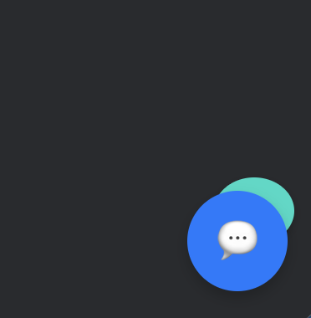
Logbook Entry: | Progress since the last entry:  Today I worked on the visual aspects of the chat bot interface, I wrote the HTML and CSS files for the chat interface (/Users/school/Documents/GitHub/angularbibleguesser/src/app/chat-bot/chat-bot.component.html and /Users/school/Documents/GitHub/angularbibleguesser/src/app/chat-bot/chat-bot.component.css). I first used Figma to work out a general design that I like the look of, I ended up picking a design that looks like the chat bot interface that Matrix.com uses for their student portal. I implemented it into the home pages and game pages (however it is not present in multiplayer games which needs to be fixed). However, I am having some issues with where the chat icon sits on the page, since currently it sits directly on top of the help icon on the main home page and I can’t seem to get it to move above or to the side, this will be something that I will need to work on next time.  Although, I still have not started writing the actual chat bot context or API calls (chat-bot.service.ts is empty), I also managed to create a local development environment to do dynamic platform testing instead of needing to upload my changes to the web after every little change I make.  Task Achieved:  Stumbling blocks or issues encountered and how they were managed:  Possible approaches for upcoming tasks:  Reflective comments:
Resources:

Date: | 16th Feb
Title: | Documentation Work
Author: | Eamon Wong
Tasks Description: | Worked on documentation sections 1 and 2
Image: | 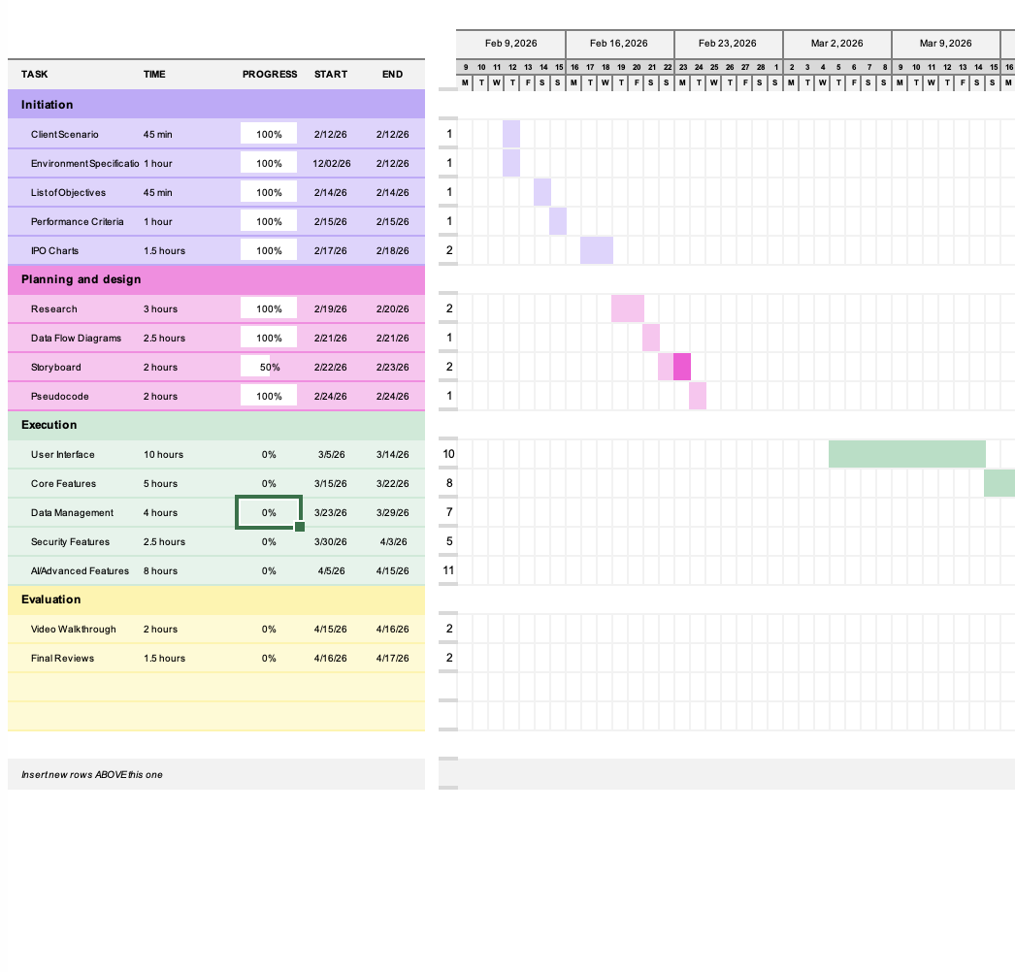  My Gantt chart.
Logbook Entry: | Progress since the last entry:  I finished the chat-bot addition to the code.  Task Achieved:  Today I started by creating a Gantt chart using a template from Excel, where I first wrote down all the tasks that will need to be done on paper first, then I transferred them across onto the spreadsheet, which I categorised by section numbers. I then added estimated times for completion for each of the tasks.  Next, I started writing the client scenario section, which I scaffolded out the main points in bullet point form. Next, I started writing the research section (2.1) for the assessment task. I started with existing applications, writing down some information about the platforms of Kahoot.it, Bibleguesser.com and blooket.com.  Stumbling blocks or issues encountered and how they were managed:  I wasn’t sure how much depth I needed to describe the research of other applications in, but I booked a tutor session with a software tutor and I managed to understand it better.
Resources:

Date: | 20th Feb
Title: | Documentation Work
Author: | Eamon Wong
Tasks Description: | Worked on completing section 2.
Image: | 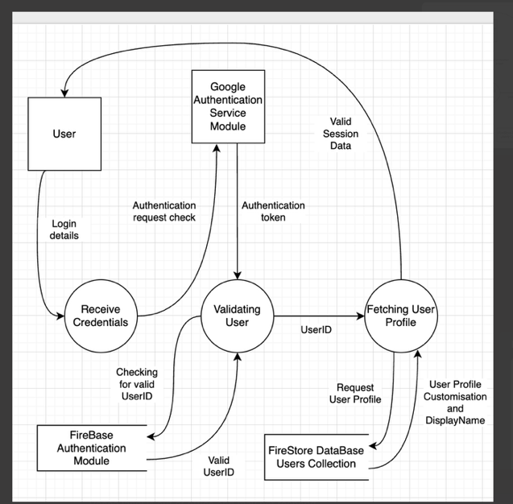  My first attempt at a level 1 dataflow diagram.
Logbook Entry: | Task Achieved:  I managed to get the whole of section 2.1 completed, with similar applications, current technologies and some relevant best practice policies.  I also started on the dataflow diagrams, I chose to do diagrams for the login, game play and statistic leaderboard processes. I created 3 different diagrams in total, which I will be getting checked by a tutor.  I also started on the storyboard, for this is used Figma, so that I could implement some prototyping for the board. I am unsure what depth I need to go into, and whether I need to only show the new content, or do all content, but I will also get this checked.  Stumbling blocks or issues encountered and how they were managed:  Some issues that I experience were figuring out how to depict the database functions (such as module authentication) to depict on the dataflow diagrams. However, I decided to watch some tutorial/explanation videos on depicting external database functions for level 1 dataflow diagrams, which helped me figure out what to do.  Reflective comments:  One thing that I am particularly proud of, are Bitwise operations. I found out about these actually while coding a Minecraft server with some friends, it took me a while to figure out how exactly it worked and the applications, but once I realised its uses, I was very excited to use it for this task.
Resources:

Date: | 24th Feb
Title: | Documentation work
Author: | Eamon Wong
Tasks Description: | Worked on documentation for section 1 and 2.
Image: | 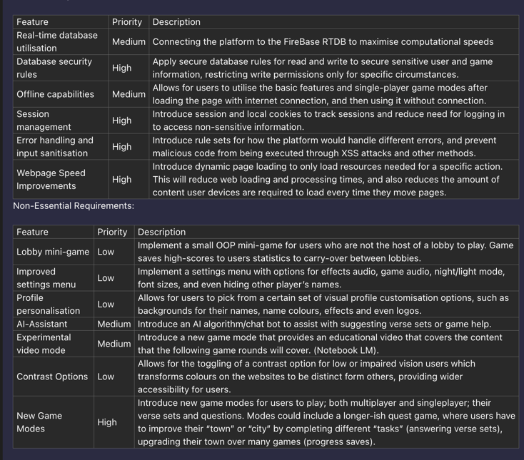  My first attempt at my functional requirements .
Logbook Entry: | Task Achieved:  I managed to complete my Gantt chart for the documentation on excel. I also started on working out my IPO tables for my 10 processes. I ended up getting the tables checked by a tutor, who helped me understand how I needed to create them properly. Similarly, I also did some work on the requirements section, making sure that I included everything from the client scenario.  However, I still do not think that my IPO charts go into enough depth about what is going on, so I did some research and found a video that explained it well which also helped. I found this especially helpful as it allowed me to rewind the video to go and rewatch/relisten to certain sections or information that I wanted to, something that I was not able to do as much with a tutor, since I would be asking the tutor multiple times to repeat something that they would say.  Additionally, I also did work on my functional and non-functional requirements tables, where I turned my requirements paragraph into a table with many different entries. This was to allow me the space to talk about the details of each point in greater depth, as well as clearly separating each point.  Reflective comments:  I feel that I am starting to run out of time, given that I have two external assessment projects I need to work on at the same time, but if I stick to my Gantt chart, I should be okay.
Resources: | https://www.youtube.com/watch?v=1zkzXgS9apE

Date: | 1st March
Title: | Documentation Work and GitHub
Author: | Eamon Wong
Tasks Description: | Documentation for sections 1 and 2.
Image: | 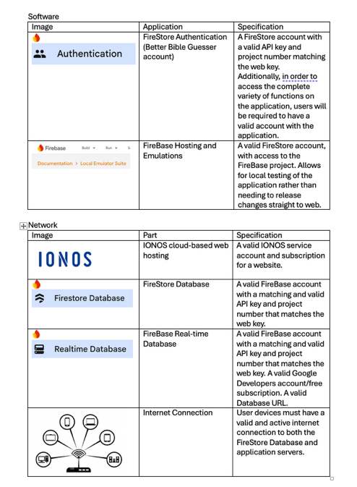  My environmental specifications.
Logbook Entry: | Progress Made:  Today, I completed my requirements definition section and started on working on the environmental specifications of the project. I also organised a tutor session to help me with my specifications, which was extremely helpful in helping understand exactly what I needed to include, and what wasn’t needed. I also worked on the performance requirements section, identifying what I wanted the final product to feature.  Today I also started my pseudocode algorithms, but I’m not sure I’m using the correct syntax, so I booked another tutor session to double check.  Additionally, I added Mr. Ianni to my existing GitHub repository, and made the repository private to everyone else.  Todo next week:  By next week, I would really like to have finished my storyboard, as I feel like that is something that is lacking a bit in detail and completion.
Resources:

Date: | 6th March
Title: | Documentation and Storyboarding
Author: | Eamon Wong
Tasks Description: | Worked on the storyboard and some documentation work for section 2
Image: | 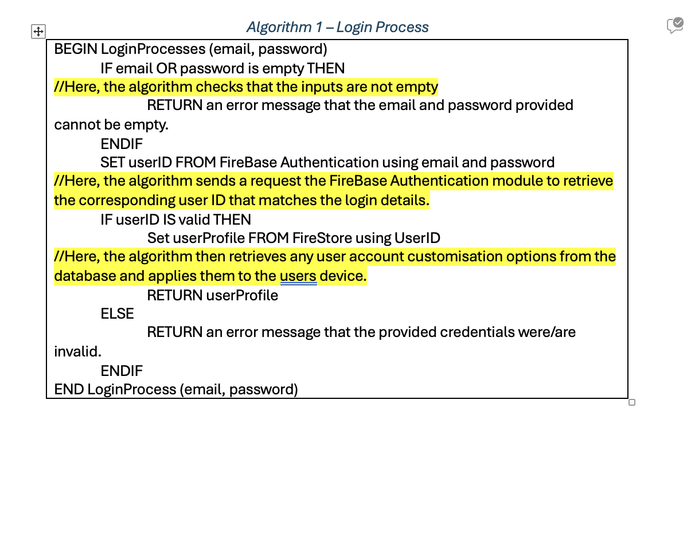  My first pseudocode algorithm.
Logbook Entry: | Progress Made:  Today I worked primarily on the storyboard, adding screens/frames for the already existing pages on my application, I also had a tutor session with a tutor, who informed me that it would be a good idea to include visual flow arrows on the storyboard as well as the hidden prototyping arrows to help with visualisation of data flow. I still have a little bit of work to go on my storyboard, but I will leave that for another day.  Additionally, today I wrote my second pseudocode algorithm for the statistic leaderboard process. I also just remembered that I need to have pseudocode comments which I will do later.  Reflective comments:  I am starting to run out of time to complete this part however, since I will need to start preparing for other school exams soon, so I need to start working faster.
Resources:

Date: | 14th March
Title: | Documentation fixes
Author: | Eamon Wong
Tasks Description: | Worked on finalising documentation.
Image: | 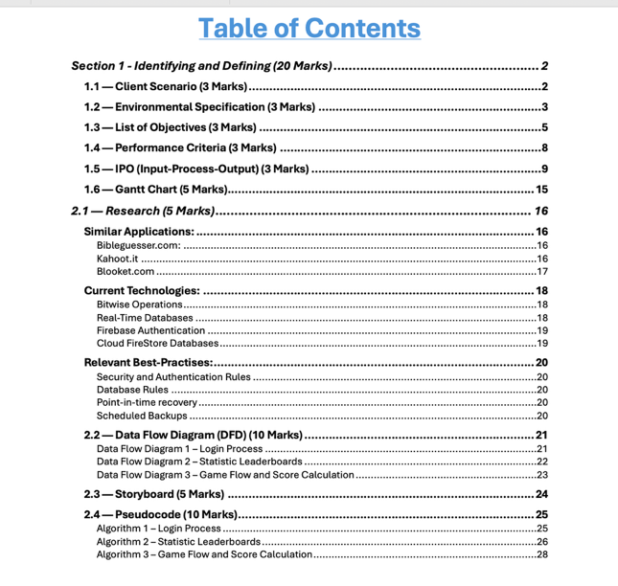
Logbook Entry: | Progress Made:  Today, I worked on completing some of the unfinished sections of my documentation, such as turning dot points in my 1.2 and 1.3. expanding on the ideas, as well as adding more.  I also extensively changed my list of objectives by over double, adding more fundamental and non-fundamental objectives to expand on key ideas that needed to be separate to other objectives, such as splitting input sanitisation and error handling into two different objectives.  Additionally, I wrote my third pseudocode algorithm on the game flow and round score calculation process. This was quite a long section, with a few sub-processes needed to fully explain and depict the data flow within the process.  Similarly, I went through the rest of the document, fixing grammar issues, and created heading weights to show on the contents page better. However, I did update the Gantt chart with the new objectives so that it better represented the project timeline.  Reflection:  Overall, as of current, I am feeling quite good with how my project is looking, only a few more aesthetical aspects really need addressing and then my project is finished.
Resources:

Date: | 18th March
Title: | File corrupted
Author: | Eamon Wong
Tasks Description: | Main document file got corrupted while saving
Image: | 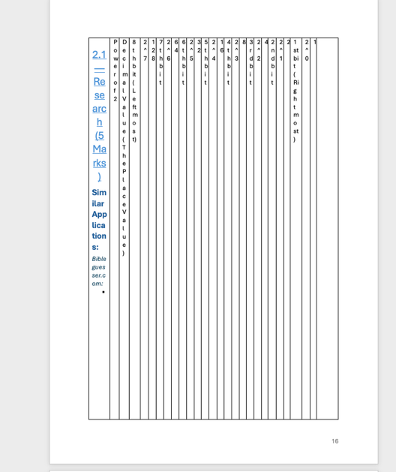  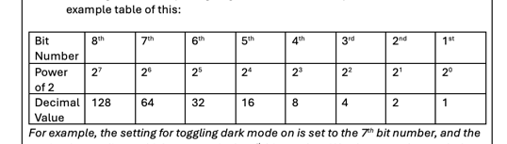
Logbook Entry: | Challenges Faced:  While saving my document after adding some changes to the research section, my word on my MacBook started not-responding, and was showing the spinning wheel of death. I had to close my laptop as the final school bell had rung. But when I got home, the wheel was still spinning. I needed to use word for something else, so I had no choice but to force-quit word and reopen, when I reopened the document, the document had become 120 pages long (instead of 30), with the research section being just a table with lots of columns and random text spread throughout making no sense, I was not able to find the majority of my work still in the remaining table, so I restored a previous copy before the corruption, and rewrote in the changes before it got corrupted.  Progress Made:  The changes I made were to the Bitwise Operations section, in which I had tried to paste in a bit-value table that Gemini AI created for me to easily show what the bit-values were in an 8-bit value. When I made the new document, instead of pasting it directly in, I wrote it in manually myself with some changes to make it more readable.  Reflection:  Overall, I now feel quite satisfied with the work that I have produce so far, and I aim to begin working on implementing these new features into my application once my exams are over in a few weeks.
Resources:

